

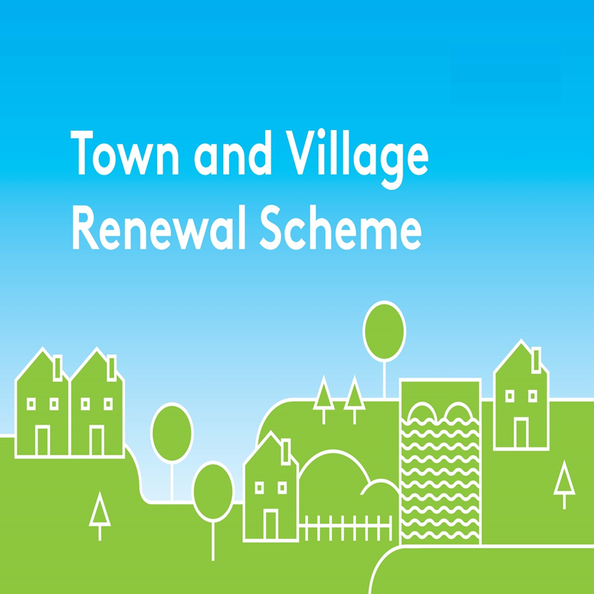

**2020 Application Form**

Please complete a separate application form in respect of each proposal.

All queries can be addressed to: [townandvillage@drcd.gov.ie](mailto:townandvillage@drcd.gov.ie)

**Application Reference No**

**APPLICATION FORM**

**This form should be completed by Local Authority personnel and returned by e-mail to** [**townandvillage@drcd.gov.ie**](mailto:townandvillage@drcd.gov.ie) **by 28th August 2020. Maximum of 6 Applications per Local Authority.**

**Name of Local Authority:**

**Town/Village covered**:

**Postal Address of project:**

**Amount of Grant Funding Requested:**

**Contact Name (Local Authority):**

**Contact email address:**

**Contact phone No:**

**Project Details:**

|  |
| --- |
| 1. **Project description (max 30 words) – Details may be used for Press Release / website:** |

|  |
| --- |
| 1. **Project Details (Max. of 300 words). A detailed project proposal may be appended to this application. (Maximum 5 Pages):** |

|  |
| --- |
| 1. **If planning permission or other special permissions are required for this project please advise on the current status of the process and indicate when permissions will be granted.** |

|  |
| --- |
| 1. **Explain the rationale for the choice of Town/Village, identify existing assets, amenities, accessibility, environmental aspect, retail mix, etc., and any deficits that need to be addressed or opportunities that can be built on.** |

|  |
| --- |
| 1. **Has this town/village received public funding previously e.g. REDZ, T&V, CLÁR, ORIS, RRDF, LEADER etc.? List scheme, year and funding amount.** |

|  |
| --- |
| 1. **Are there any other applications pending for public funding for this project?** |

|  |
| --- |
| 1. **If this town/village is also the subject of an RRDF application, explain the rationale for submitting this application to the Town and Village Renewal Scheme and how this links with the RRDF application.** |

|  |
| --- |
| 1. **Who will be implementing the project? Please provide details of other stakeholders involved.** |

|  |
| --- |
| 1. **Please provide details as to how this project will make a positive and visible impact on the town/village**, **including specific details as to what will be delivered when the project as funded is completed e.g. all windows replaced in community hall.** |

|  |
| --- |
| 1. **How will the intended outcomes be measured? (Please supply any metrics or benchmarks that will be applied).** |

|  |
| --- |
| 1. **If seeking funding of greater than €100,000, please provide details of how the project will deliver exceptional benefit to the town/village.** |

|  |
| --- |
| 1. **When will work on the project commence and how long will the proposed work take to complete?**   **Proposed commencement date:**  **Proposed completion date:**  **How many weeks will it take to complete the project:** |

1. **Financial Details:**

|  |  |
| --- | --- |
| Local Authority VAT No |  |
| Tax Registration No |  |
| Tax Clearance No: |  |
| CHY Number (if applicable) |  |

**PROJECT COSTINGS:**

1. Please provide detailed breakdown of all elements of the proposed works including any administration/other fees/costs:

|  |  |
| --- | --- |
| (**Itemise various elements)** |  |
|  | € |
|  | € |
|  | € |
| **Total Project Cost** | € |
| **Grant Aid amount sought:** (Max of 90% of Total project cost | € |
| **Match Funding:**  **(Minimum 10% of total cost)** | € |
| **Amount of Cash Contribution:**  **(Minimum of 5% of total cost)**  **To be supplied by:** | € |
| **Amount of In Kind Contribution:**  **(Max of 5% of total cost)**  **Form of In-kind Contribution (Provide details):**  **To be supplied by:** | € |
| **Any other relevant information:** |  |

Please ensure that the following 3 forms are returned to the Department by 28th August 2020:

**(i) Application form**

**(ii) Application Overview sheet and**

**(iii) The Expression of Interest Overview sheets.**

Please ensure that these forms are fully completed as an incomplete application may result in the project not being considered. Please return completed forms by e-mail to [**townandvillage@drcd.gov.ie**](mailto:townandvillage@drcd.gov.ie)by **28th August 2020.**

**DECLARATION**

I request that assistance be given in support of the project as outlined and certify that, if made, the grant will be solely for the purpose for which it is approved. I confirm that the particulars of this application are correct and that the Local Authority confirms:

* that match funding is in place and that evidence and source of the match funding is held;
* that necessary permissions are in place or in train;
* that evidence of ownership/lease (if applicable) is in line with Scheme Outline;
* that a consultation process was undertaken with representatives of the community or business interest of the town/village and that the project was identified through the consultation process undertaken;
* the relevance of project to the LECP/other plans; that resources are available to provide for ongoing maintenance of the project, if applicable;
* that all tendering processes will comply with Public Procurement Guidelines;
* that the project is not double funded.

Proof of the above is not required at the time of application but must be held on file by the Local Authority and must be available to the Department or its agents on request.

**Signed: _________________________ _________________________Local Authority Director of Services**

**Date:_________________________**