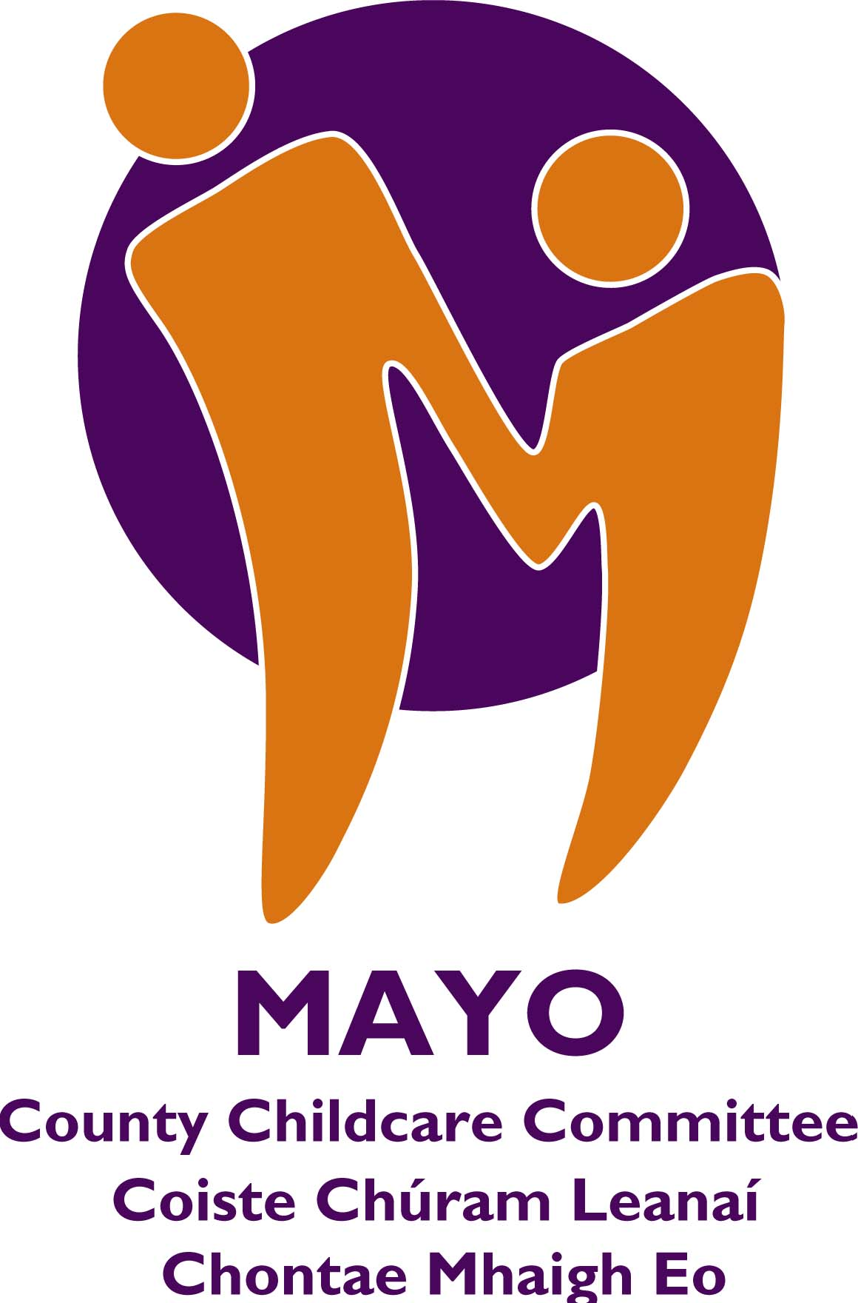

Parent & Toddler Group Initiative
Grants & Toddler Groups

Note:
These Guidelines were applicable to the Parent & Toddler Grant funding in 2019 and may change slightly for 2020 when Parent & Toddler funding is announced. If you wish to set up a new Parent & Toddler group, it is advised to contact Mayo County Childcare Committee.

Information on grants available:

Applications for funding under this scheme should only be made by Parent & Toddler Groups that are organised on a not-for-profit basis and involve the participation of parents in the community. Grants will normally range from €100 to €1,000. Existing groups can apply for a maximum grant of €800. New start up groups may apply for a maximum grant of up €,1000.

Funding will be available for:

- Toys, equipment and books.
- Training for parents, e.g. paediatric first aid, committee skills, parenting courses.
- Children’s activities, e.g. arts and crafts, music.
- Limited funding will be available towards insurance, rent or minor refurbishment, up to a maximum of 30% of total funding.

Funding will not be available for:
- Groups operating out of private homes.
- Once off events such as outings, parties and trips.
- Groups with a closing balance of €3,000 or more in the previous year.
- Groups who received funding in previous years and did not return the Progress Report and receipts for items purchased .
- Groups who do not submit evidence of appropriate insurance when making their application.

Additional Information:
- P & T Groups should have a Bank Account/Credit Union Account. The money taken at each session, any grants received by the group or money received from fundraising should be paid into the account. It is recommended that spending on the group’s behalf should be paid for by cheque/draft. All transactions involving the group’s money should be recorded and all receipts kept.
- Applications from P & T Groups will only be accepted from groups known to Mayo County Childcare Committee, new groups should make arrangements to meet a County Childcare Committee staff representative prior to application deadline.
- P & T Groups must submit evidence of appropriate insurance (not applicable to new groups). Recommendation: set a criteria that new groups will have to submit evidence of insurance within the first month of receiving the grant.

How to apply:
- Please detach and fill in the attached application form, using clear block writing.
- Please ensure that all sections are completed (Application form, Annual Income & Expenditure Account, Progress Report).
- Simple financial records are important for groups in receipt of grants as they offer protection for all involved However, newly formed groups do not need to provide a financial record until they are in existence for one year.
- Please ensure the application is signed by 2 committee members .
- Applicants are required to submit up to date bank statement/credit union statement (no older than 2 months) with their application form.
- Forward evidence of insurance with application.
- Forward evidence of receipts for items purchased with last grant, along with progress report.
- Grant Applications will not be recommended if they do not include adequate information, i.e. all sections of the application form must be completed.

Post Approval Information:
- Successful applicants are required to submit receipts as evidence of expenditure.
- If a P & T Group wishes to change their approved expenditure, they must apply by email to Mayo County Childcare Committee prior to purchasing new item. Mayo CCCs decision will be confirmed by email.
- Successful applicants may receive a support visit from the local CCC.

What Mayo County Childcare Can do for you:
Mayo County Childcare is available to support anyone wishing to set up a parent and toddler group or those currently running one. We can provide information which promotes the provision of a quality service that runs smoothly and conveniently for all the children and parents attending. We can assist you in choosing toys and activities which are developmentally appropriate; encourage adult child interactions or we may be able to put you in contact with relevant agencies or organisations.

Important dates:

- Application forms to be returned by a certain date as indicated by Mayo CCC..
- Notification of decisions and payment of grants will be made by a date set by Mayo CCC

This form may be photocopied, if required.
Send completed form to:
Grants for Parent & Toddler Groups,
Mayo County Childcare Committee, First Floor, Chambers House, Ellison St, Castlebar, Co Mayo

- Please note you can email in your application also (ensure it is signed copy)

Phone: 094 9064396 Email: maryconway@mayococo.ie
Website: mayochildcare@mayococo.ie Find us on Facebook:

APPLICATION FORM

Parent & Toddler Group Initiative Grants 2019

[Please use block letters]

NB Please write name of group as it appears on bank/credit union/post office account.

- Name of Group: -

- Address of Group: -
NB Please write name of venue where your group meets weekly.

- Name and details of two contact people (preferably committee members) (please include address, phone/mobile & email for each): -
Name:

Address:

Phone:
Mobile:
Email:

Name:

Address:

Phone:
Mobile:
Email:

- Contact name and number for the group: ______________________________
Note: This number will be made publically available

- Amount of grant being sought from City/Childcare
€
Committee (to a limit of €1,000 new groups: €800 existing groups)

- Detailed breakdown of costings for grant being sought:- (Example: €1,000 being sought; €200 toys, €200 insurance, €200 training, €200 rent, €200 equipment)
________________________________________________________________________________

___________________________________________________________________________________________

___________________________________________________________________________________________
- Annual cost of running the group: -
€

- How often does the group take place? (Please include day and time for our records)

_______________________________________________________________________________

- Do you charge participants? Yes___ ⁭NO____
€
If yes, what is the charge per session?

- Do you pay an annual rent for premises?
€
If yes, how much and to whom is rent paid?

Funding Agency

Amount €
- Details of funding received in the past year: -
(e.g. CCC, HSE, local fundraising, other)

- If funding was received from Mayo Co Childcare Committee
in 2018 have you returned your Progress Report?
(If ‘NO’ please forward this Report immediately) YES NO

- Details of unsuccessful funding applications in the past
Funding Agency

Reason
Year:
(please give reason):

Funding Agency

- What other agencies have you applied to for future
funding?

- When was the Parent & Toddler Group formed?

- On average how many adults attend the group each week?

- On average how many children attend the group each week?

- How many people are involved in the committee?

- Name of the Insurance Company & Insurance Number
(Please enclose copy of Insurance)

_________________________________________________________________________________________________________
Annual Income and Expenditure Account 2018
(Newly formed groups do not need to provide a financial record until they are in existence for one year)

NAME OF GROUP:
TIME PERIOD:
Opening Balance in Account: |  | €
Income 2018 |  |  | Expenditure 2018
Parent & Toddler Fees 2018 |  |  | Rent
Fundraising 2018 |  |  | Heating
Grants Rec'd in 2018 |  |  | ESB
----------County Childcare Committee |  |  | Insurance
HSE |  |  | Telephone
Other (please specify) |  |  | Toys and Equipment
 |  |  | Snacks - tea & coffee
 |  |  | Activities (please specify)
 |  |  | Training
 |  |  | Other items
Total | € |  | Total | €
Closing Balance: |  | €
Signed: ________________________ | Date: ____________
Treasurer/Committee Member

PROGRESS REPORT

Name of Group:

Amount of funding Allocated:

1. Please give breakdown on how the funding was spent:
(Example: €150 insurance, €75 books; €150 toys)

2. Describe the benefits the grant made to the group

3. Any additional information which may be of relevance.

Signed (Chairperson or committee member)

____________________________________________________

Date ___________________

Please return completed form before 24/4/20
To:

N.B.
APPLICATIONS WILL NOT BE CONSIDERED IF ALL SECTIONS OF THE FORM HAVE NOT BEEN COMPLETED

DATA PROTECTION DECLARATION

As soon as you contact __________ County Childcare Committee we will create a computer record in your group’s name. Information that you provide is added to your record.

The information you provide may be used for the following purposes:
- CCC database and directory of services
- Recording queries and information and advice given
- Processing of funding applications
- Compiling statistical information to help us improve our services and share information with the Department of Children and Youth Affairs and Pobal.

To give you an example of disclosure: Mayo County Childcare Committee is required to give funded groups names and certain other data to the Department of Children and Youth Affairs and Pobal. The Department and Pobal, in turn, observe strict rules of disclosure that are registered with the Office of the Data Protection Commissioner. County Childcare Committee will adhere to its data protection policy.

Disclaimer: This information is provided to you as part of a funding application. Although every effort has been made to ensure the accuracy of all information published, Mayo County Childcare Committee cannot accept any liability or responsibility for any errors or omissions. Mayo County Childcare Committee will bear no liability or responsibility, direct or indirect, for use or misuse, of any information in this application for funding.

I have read and understood the above statement and consent to the use and disclosure of data and information as outlined above.

Signature _______________________________________________

Position _______________________________________________

Date __________________________________________________

