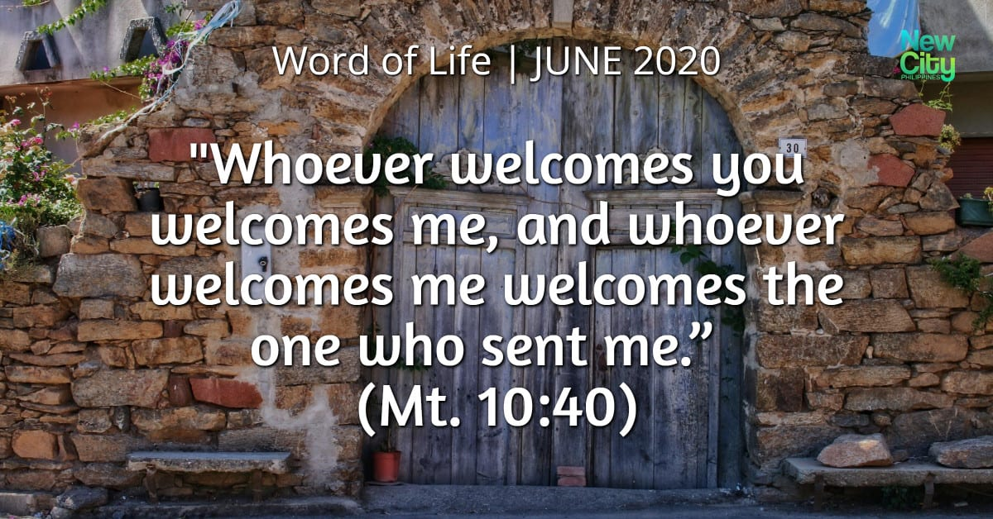

**Bohola/Shraheens Newsletter**

**Stephen O’Mahony PP – 094-9384115/086-8226405 –** [**boholaparish@gmail.com**](mailto:boholaparish@gmail.com) **(email for newsletter)**

<https://www.mayo.ie/news/category/connect/parish-news/bohola-parish-news/>

**13th Sunday in Ordinary Time – 28th June 2020**

***Church Re-Opening***

*Because of the complexities involved, (see* [*https://achonrydiocese.org/returntoworship*](https://achonrydiocese.org/returntoworship)*) no date has yet been set for the resumption of public Masses in Bohola church. However, progress is being made and in that regard we thank all those who have responded to the appeal for volunteers whether by email, by text, verbally or by attendance at our meeting on last Wednesday evening. The door is not closed to additional volunteers and all will be needed. The signs are encouraging and the church will open again but in a timely rather than a rushed manner. For now we ask you to take note of the following points:*

* *All volunteers, Ministers of the Word (Readers), Ministers of Holy Communion and anyone else who has an active role in the church are required to complete a “Return to Work” form which is available at the back of the church or by email on request. Completed forms are to be returned to the Parochial House or via email.*
* *A number of videos are available to view at* [*https://achonrydiocese.org/trainingvideos/*](https://achonrydiocese.org/trainingvideos/) *which will give you some idea of what the “new normal” will be like.*
* *A Fogger has been ordered (not yet delivered) which will decontaminate the church quickly and efficiently after every Mass.*
* *As of now, 50 is the maximum number that will be allowed to attend Mass even if the two meter physical distancing rule would allow for more.*
* *The obligation to attend Mass on Sundays continues to be suspended until further notice.*
* *Because numbers attending will be limited, we ask that you might consider coming to a weekday Mass rather than on Sunday.*
* *Anyone in the vulnerable category is advised to avoid larger gatherings so a weekday Mass may be the wise choice for your own safety.*
* *Anyone with COVID-19 symptoms and those with cold or flu-like symptoms should stay at home.*
* *Measures are being considered that will hopefully avoid having to turn anyone away from the church. Should there be an overflow, it will be possible to hear Mass on the outside speakers or to sit in your car and watch the online streaming and then receive Communion after Mass.*

*The Pastoral Council will meet again this week and endeavour to move the process forward. You may contact any of the members if you wish to volunteer, make suggestions or give feedback on any aspect of the process. You can do likewise by email to* [***boholavolunteers@gmail.com***](mailto:boholavolunteers@gmail.com)*. Finally, thanks to everybody for your co-operation, understanding and patience. More of that will be needed!*

***Helplines***

**ALONE COVID-19 Support Line for Older People:** ***0818 222 024*** (Every day, 8am to 8pm).

**Society ofSt*.* Vincent de Paul:** Call ***(091) 563233*** or email [***info.west@svp.ie***](mailto:info.west@svp.ie) or visit our website at [***www.svp.ie***](http://www.svp.ie/).

**COVID-19 Collect, Deliver & Transport Service:** Contact Local Link Mayo on ***094-9005150 / 086-0293278*** or [***mayo@locallink.ie***](mailto:mayo@locallink.ie).

***St. John’s Ambulance Mayo Division Volunteers:*** Contact Michael Corrigan on ***087-3392528***.

**COVID-19 Community Outreach Champion:** Caroline Wilson, ***086-2899296*** or [***wcaroline79@gmail.com***](mailto:wcaroline79@gmail.com).

**The Mayo Council HELPLINE** is open from 8am-8pm 7 days a week ***094-9064660***.

**ACCORD COVID-19 Relationship Support Line:** Free and confidential on ***01-5313331 / 028-95680151 / 01-9059555***. The lines are open from 9.00am to 8.00pm Monday to Friday.

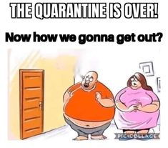***Support Pope Francis' COVID-19 Emergency Fund:*** Your help is urgently needed to help overseas missionaries and vulnerable communities to defend themselves against COVID-19. In Africa, Asia and Latin America the Church is often on the frontline. In remote, inaccessible areas, it is missionaries who respond, as best they can, to the medical and pastoral needs of suffering men, women and children. Missionaries already face too many challenges; working in over-crowded communities with no running water, in shantytowns and refugee camps where social distancing is impossible and where self-isolation could mean starvation.

To help protect these fragile communities, Pope Francis has announced the COVID-19 Emergency Fund. If you can, please give so that our less-fortunate brothers and sisters have a fighting chance at suppressing COVID-19. Donate by going online at *www.wmi.ie/covid-fund* or call Fiona on 01-4972035.

***Newsletter*** continues to be available in the church and in Clarke’s shop/Post Office, online on the *Mayo.ie* website and will be sent via email to anyone who requests it.

***Recent Death:*** Please pray for the happy repose of the soul of *Fr Paddy Kilcoyne*, Tubbercurry and formerly of this parish, who passed away on Friday, 19th June and whose funeral took place in Kiltimagh on Sunday last. May he rest in peace.

***Mass Intentions:*** Mass on this Sunday, June 28th, will be offered for *Willie Brennan and Claire & Paddy Hope****.***

Mass will be offered privately during the week for *All the People of the Parish*.

Mass on Friday, July 3rd will be offered privately for *Irene Grady and deceased of McGuinn & Grady families*.

Mass on Sunday next, July 5th, will be offered for *Marion Clarke, Bohola & deceased of Clarke & McDonnell families* and for *Annie & Martin Groarke, Ballyglass and deceased family.*

***Live Streaming of Mass from Bohola Church*** continues every Sunday morning at 10.00am on the *Bohola Post Facebook Page*.

***Parish Pastoral Council*** will meet (socially distant) in the church on Tuesday evening next, 30th June at 8.00pm, to continue planning for the re-opening of the church for public worship. All members are asked to attend.

***Offertory Envelopes:*** New boxes of envelopes for the year ahead will take effect from next Sunday, July 5th and are now available to collect in the church. It is a new list as only those who used the envelopes to contribute were included. It is acknowledged that others do contribute but choose not to use the envelopes. If anybody has been left out in error, please let us know and it will be put right immediately. New contributors are always welcome and will get envelopes on request. Sincere thanks again to all who continued to make their offerings during the lockdown.

***Sixth Class Graduation:*** On Saturday last, June 20th, the Sixth Class of Bohola National School (Rebecca Commons, Stephen Conlon, Ryan Hale, Nadine MacNicholas, Katie Mae Meehan, Taylor Osborne, Tomos Stone and Clodagh Towey) celebrated the end of their Primary School years with their families, school Principal, Mrs Teresa Mulligan and their teacher, Ms Patria Jordan. It was a Graduation with a difference in what has been a very different year for all of us. Held in the school yard with appropriate social distancing, it was great that the class could get together for one last time. A tree was planted, balloons released, a blessing bestowed and all class members received goodie bags including lovely mementoes of their time in school and all rounded off with the ice cream on the cake, so to speak!

We thank the class for all they contributed to the life of the school over the last eight years and as they move on to pastures new, we wish them every success and blessing in the years ahead. And we wish the staff and all pupils a fun, restful and well deserved Summer break. That includes the home-school teachers as well!

***Bohola N.S. Enrolment September 2020:*** Bohola N.S. is now accepting Enrolment applications for September 2020. Please email the school for an application form at [*boholaschool@gmail.com*](mailto:boholaschool@gmail.com).

***New Pilgrim Path Website of the Week, June 28th:*** Listen to the complete Bible in one year! The NIV Audio Bible, beautifully recorded over 200 hours by British actor, David Suchet (of *Poirot* fame), is the first full-length audio version of the Old and New Testaments recorded by a single voice. You can access it at[*www.newpilgrimpath.ie*](http://www.newpilgrimpath.ie/).

***Galilee Spirituality Centre:*** *A Community of Prayer:* We gather as a virtual community of prayer each Thursday from 9.00 to 9.30pm to pray for all affected by the current pandemic. We are also continuing our Taizé Prayer on the last Friday of each month from 9.00 to 10.00pm. We invite you to join with us at those times, and let us know you are there, and anything you would like us to hold in prayer. Our website is *www.galiliee.ie*.

***Moy Davitts 50/50:*** Congratulations to Susan Heneghan, Breaffy, Castlebar on winning €407 in the Moy Davitts 50/50 draw. A huge thank you to everyone who supported last week's draw, it is greatly appreciated. Tickets are available in the usual retail outlets and by clicking [*http://bit.ly/MoyDavitts50-50*](http://bit.ly/MoyDavitts50-50). It might be you !!!

***Free Online Living Well Programme*** commences on *Wednesday, 1st July* from 10.30am to 1.00pm (Limited places).If you are living with a long term heath condition, you may be interested in doing the ‘Living Well Programme’. This is a six week programme delivered in 2.5 hour weekly sessions where you will learn new skills to manage your health condition on a day to day basis. This Programme will commence on Wednesday, 1st July from 10.30am to 1.00pm. You must register in advance as places are limited to 10/12 participants. Please note, you do not have to disclose your health condition on the programme. Please contact Liam Gildea on 087-3490393 or by email at [*liam.gildea@mayocil.ie*](mailto:liam.gildea@mayocil.ie). You can find out more information on the programme on our website: [*https://www.hse.ie/eng/health/hl/selfmanagement/living-well-programme/*](https://www.hse.ie/eng/health/hl/selfmanagement/living-well-programme/).



***Wife: Did I get fat during quarantine?***

***Husband: You were never really skinny!***

***Time of Death: 11.23pm – 26/06/2020.***

***Cause of Death: COVID-19!***